Final Project Design Phase
Computer Science - Week 11
Oct 3, 2026 - Version 0.0.4

For complete instructions and project ideas, refer to the assignment in Canvas. Specifically, review the final project requirements before you continue below. If you have not reviewed the project requirements in Canvas (you might have to go to the modules view and check the current or past week's content), you will not be able to properly complete the parts below. In addition, it may be helpful to review the information on this Drafter documentation page.

0) Project Planning and Preparation
Successful programmers spend time planning before they begin coding. After reviewing the project requirements, answer the following questions to help guide your design and development process.
- What concepts from class or previous assignments might help you complete this project? Which programming concepts (loops, conditionals, lists, classes, etc.) do you expect to use? What programming skills do you want to improve while completing this project?
“Guess The Word” or “Poker” and “Story Teller” because they are examples of games where you have an input and the change/result depends on what that input was. Also, the Story Teller one stores your input somewhere, similar to how I will have to store which answers were right and wrong. Dataclasses will help me by having flag images, names, and regions all attached together. I want to improve my drafter skills.

- Which parts of the project do you expect to be the easiest for you? The hardest? Why?
The multiple-choice options and country flags, and randomly picking them, dataclasses, and storing which answers are right and wrong will be easiest because although they might be boring and mundane, I already know how to do most of it. The hardest thing will be formatting it on the screen and doing all of the drafter/route work because I am not that good at this yet.

- Even though you have not yet designed the final project, estimate which tasks will likely require the most time and effort? Which features or components should be implemented first?
Implementing all of the information (name, region, and flag image url for each country). There are 195 countries so this will just take a long time. But, this should be the first thing to do so it is easier to test other functions. Another thing that might be hard is having it randomly select country flags and names and have one of the answer options be correct. The hardest part might be the UI side of it and making it all look good.

- What distractions might interfere with your work and how will you minimize them? What resources will you need available while working? What questions, if any, do you still have about the assignment requirements?
I have a couple very busy weeks and do not have much free time, along with having a roommate who goes to sleep at 7PM and wakes up at 4AM so it is hard to find a place to work in peace sometimes.

1) Site Diagram
Create a mock-up of your planned website. We suggest you make the mockup on paper, although you can also use software like PowerPoint or Slides to make a mockup. There is other design software that could also be used, but we strongly encourage you to keep it simple. Do not spend more than 15-30 minutes detailing the mock-up. Your goal should be to make a very quick and dirty diagram, to show that you have some kind of idea.

We recommend drawing each page as a rectangle, and laying out the text, buttons, and other components inside. Then, use arrows to indicate links between pages. Label each page the way you will name each function, and then put labels on the arrows to indicate what the button links. Also write down any parameters that should come into the pages.

In addition to the pages and routes, write down what fields your `State` will have, both their names and types. Think clearly about what data will need to be persistent across the entire website.

Add photo(s) or screenshot(s) of your website mock-up and labeled diagram on the next page. 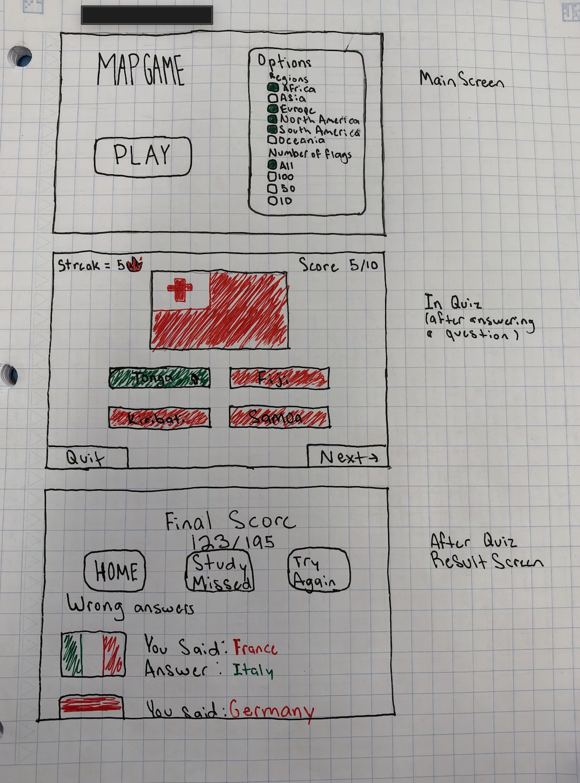2) Implementing Requirements
This table should serve as a draft for how you will implement the requirements into your final project. You may change your ideas later on, but your final site must fulfill all the requirements.

Requirement | Implementation
Purpose/Functionality  A 1-2 sentence description of the purpose or functionality of your site | To be a fun game that teaches users the flags associated with the name of each country. Allows you to have an easy/fun way to learn them.
State Dataclass Attributes  Minimum of 4 attributes, one of which must be a list/dict of instances of your second dataclass.  Briefly describe each attribute, its type, and how it will be meaningfully modified throughout the site. | Countries: list[Country]  Current_index: int  Score: int  Streak: int  Missed: list[str]
Second Dataclass  Your second dataclass, including its attributes, their types, and how they will be meaningfully modified (if they are modified) | Class Country:  flag_image: str  name: str  region: str
Routes (minimum 7)  The names of your route functions | Index  Choose_region  Question  Check_answer  Feedback  Results  restart
Pages (minimum 5)  A brief description of the pages in your site | Home Page: start page where you can play quiz or change options  Options Page: full screen page of options where you can choose which regions and number of flags  Question Page: shows the flag and options  Answer Page: similar to Question Page but shows you are correct or incorrect  Feedback Page: gives results of quiz and option to try again, home, or practice missed
User Input (minimum 3)  Description of user input components (TextBox, TextArea, CheckBox, or SelectBox) and their purposes  For more information on these input types, see Drafter Documentation. | SelectBox (regions) - lets player choose which regions of flags are on the quiz  SelectBox (answer) - choose which country flags are correct  SelectBox (number) - choose number of flags/questions in the quiz
If Statements (minimum 3)  Brief description of what will be evaluated in your if statements and how they will meaningfully change the logic of the site | Answer check: if the guess = country.name then the score and streak go up one and country is added to correct list, else the streak resets to 0 and country is added to the missed list  Region filter: if the region is selected, then include those countries flags in the quiz  Number filter: if that number of flags is selected in options, that is the amount of questions in the quiz  End of game: if there are no questions left, take to the results page
Loop (minimum 1)  This loop must iterate over the list/dict of dataclass instances in your State attribute.  Description of this loop and why it is meaningful to the site | For loop goes thorough list of countries and filters through to create a list of countries that apply to the filters selected.  For loop that goes through the list of approved countries and randomly selects a correct answer  For loop that goes through country names to select the options for answers

LLM Conversation
If you used an LLM in any part of this work, copy and paste every part of that conversation below. Otherwise, you may be given a zero for the assignment. Obviously, these words will not all be yours, and this is the exception to the requirement at the top of this assignment that all responses be in your own words. If you did not use an LLM to assist you in this assignment, simply say so below.
I did not.

Final Submission
When you are finished, download this file as a Word Document (docx) and upload the file to the appropriate assignment on Canvas.

